TAT2 Task 3: Instructor’s Manual

Jeremiah J. Jackson
15 March 2019

A Written Project Presented to the Faculty of the Teachers College of
Western Governors University

Table of Contents

Unit Overview 3
Instructional Goal 3
Instructional Sequence 4
Delivery Approach 5
Materials Needed 5
Lesson plans 9
Lesson 1 Overlapping 9
Lesson 2 The Three Parts of Space 11
Lesson 3 1 Perspective Drawing Method 13
Resources for Instruction 16
Type chapter title (level 3) 6
References 1

Unit Overview
TAT2 Task 1: Integration Design
Perspective drawing is an invaluable skill that most art students need in order to draw the world around them in a believable way. This unit is projected to encompass ten to eleven days of instruction and hands on activities. The course is designed for any beginning student of drawing but will focus on 7th to 8th grade levels. Details of the course will be introduced in the following sections.
This unit of study addresses the need for beginning visual art students to have some fundamental drawing skills in order to be confident and successful in drawing. It will also enable them to make informed guesses when faced with drawing problems in many of subsequent units in the art 1 course.
The unit is broken down into three lessons covered in ten to eleven 48 minute class periods. The first addresses the skill of identifying and using overlapping in an image. The second breaks the image into foreground, mid-ground and background and helps students understand the need to consider each in most images. The third lesson will introduce the art method of one perspective to the students and allow them to experiment with this key drawing tool.

Instructional Goal
Upon completion of the unit of instruction students will render an image using 1 or 2 point perspective drawing methods with no more than 7 lines drawn contrary to the guiding rules of the method. This assessment will be gaged on 100 attempted drawn lines.
Students will also use the basic enhancement techniques of size relationships and overlapping more than three times respectively in the image to create believable three-dimensional images.
Instructional Sequence
There are three lessons starting with overlapping objects, this concept is basic to the other lessons and will be built upon as each new lesson is introduced. Lesson two covers foreground, mid-ground and background and why it is important to consider each place in an image. The final lesson covers the one point drawing method and gives students a tool that can be used to tie all three lessons together. Each lesson will use lecture demonstration and a variety of activities to help create student interest.
Performance Objectives
Performance Objective 1: After participating in a follow-along drawing exercise, students will overlap objects instead of drawing them separately. Assessment will be reviewed in practice activities and in the final drawing.
Performance Objective 2: After participating in a follow-along drawing exercise, students will draw objects in fore, mid and background. Assessment will be reviewed in practice activities and in the final drawing.
Performance Objective 3: After participating in follow-along drawing exercise, students will draw objects receding into the background following the 1-point perspective technique with no more than five errors in 30 drawn lines.
Performance Objective 4: Using the skills practiced in follow along demonstrations and practice activities students will draw a believable cityscape image that contains at least 3 buildings and that shows overlapping and fore, mid and background concepts with a minimum of 10 out of place lines.

Delivery Approach
The primary instructional strategy used in this unit is a hands-on approach. Students will engage in follow along activities designed to show them new techniques used to create the various visual effects. Part of these demonstrations will include discussion on how students might use each new concept with previous drawing units. There will be bell activities and problem solving activities designed to stimulate deeper learning when using the technical drawing methods. Students will also participate in a one on one critique activity prior to completing final drawings.

Materials Needed
- Classroom sets of basic drawing tools
Pencils
Rulers
Drawing paper
Illustration board (for drawing surface)
Colored pencil sets (need red, green and blue)
Erasers
Tape
- Whiteboard and multiple color white board markers.
- Have image resources available for unprepared students (magazine or printed internet images).
- Slide presentation on space and depth of field.
- View finders made from matt board. (frames cut 8”X6” with a one-inch boarder)
- Slides showing linier perspective vs. parallel perspective.
- Digital images placed on a power point (examples of projects, discussion images).
- Access to internet. Students will use provided Chromebooks.
- Google accounts. (All students have Google accounts in instructional setting).
- Access to https://www.instantstreetview.com/
- Document with addresses or locations and links to choose from on https://www.instantstreetview.com/
- Worksheet on foreground, mid-ground and background.
- Individual sketchbooks or half sheet of paper for students who have misplaced sketchbooks.

Lesson Descriptions
Lesson 1- Launches students into the realm of visual illusions. A simple line drawing can create an illusion by simply drawing a new object that starts and finishes at the edge of the first object. When this is done correctly it appears as if the first object is in front of the second object. There are many simple variations of this concept that can be shown to students so that they can use them in their personal visual studies.
Lesson 2- Is an extension of lesson 1. It divides the drawing surface into visual planes that help students identify where in a drawing our natural vision places objects. By identifying these locations students gain a better sense of depth and can place objects in a scene in a believable fashion.
Lesson 3- Introduces a technique that uses a drawing technique that mimics the way our eye sees the world. The techniques covered in the two previous lessons are very useful in creating a finished image that is not only scientifically correct but visually interesting as well.
Assessment of Student Performance
Assessments will be given in a variety of ways. Drawings will be used to demonstrate understanding from each lesson.
Lesson one assessment will be taken by reviewing student drawing notes highlighting any discrepancies and returning prior to final lesson assessment. Final assessment will be to draw objects from previous drawing units and intentionally overlapping them into interesting compositions. Students can use objects from personal image collections instead of previously drawn objects.
Lesson two assessment will be made by reviewing student drawings and ensuring students have labeled parts of the foreground, mid-ground and background correctly. The image that students draw we be obtained by students using provided viewfinder frames to find a scene that contains good examples of each part of the drawing plane. Students can add objects to scene to fill requirement of drawing five objects in each section.
Lesson three will assessed first by a peer review with another student, this will happen on day three so that students can use any feedback in their projects. The final drawing will be completed by visiting one of the map locations provided. In the chosen 360-degree digital environment students will use the skill of scene selection learned in lesson two. This will help them find an interesting viewpoint to use their knowledge of one-point perspective to draw an interesting image. They criteria for mastery involves following the three main rules of the technique. Lines that go up and down are parallel with the sides of the paper. Lines that cross the view are parallel to the top and bottom of the page and all other lines should be drawn converging upon the vanishing point. Deviating from these rules constitute errors that will be tallied. Elements from the previous lessons will also be reviewed in the image. No marking will be done on these images as they are considered works of art.
Delivery Strategy
Lectures, demonstrations and instructions will be voiced by the instructor. Students will have access to the instructor, computer links and hard copies of materials needed to be successful in this block of study.
Demonstrations will be completed on a white board with students following along step by step on paper. These demonstrations will be interactive with questions and feedback being given throughout. Quiet peer tutoring will also be allowed as students sometimes struggle with the drawing methods and the instructor cannot reach each student during the lecture.
Computer resources will be supplemental to the hands-on activities experienced in the course. Students will be able to access review material, to help understand the drawing methods. They will also be used to find reference images and share work in a digital gallery.
Most of the coursework will be completed in class, students can work independently after tasks are assigned. There will be collaborative portions throughout instruction, with students giving feedback in the form of critique. Most work will be completed individually.
Instructional Materials
Instructional materials such as worksheets, handouts, or printed hard copies are available in the Appendices section.
- Bell question half sheets for students missing sketchbooks. “What do you know about depth of field and space in works of Art?” (Lesson 1)
- Power point/slide, “Notes” for step by step activity for overlapping material. (Lesson 1)
- Power point/slide, “Space and Depth of Field” (Lesson 2)
- Assessment worksheet “Foreground, Mid-Ground and Background” (Lesson 2)
- Power point/slide, “Parallel Perspective vs. Linear Perspective” (Lesson 3)
- Assessment worksheet “Drawing around the World” (Lesson 3)
- Hardcopy of Study Resource sheet / “WeberTube” links

Lesson Plan #1 Title: Overlapping
Time: Three 45-48 minute class periods
Performance Objective: Students will be able to discern object placement and size in relation to the whole image and learn how to render the same visual effect.
Resources or Materials Needed:
Students:
Pencil
Eraser
Paper
Sketchbook
Instructor:
Bell activity question written on board and half sheets available for students missing sketchbooks “What do you know about depth of field and space in works of Art?”
White Board
White Board markers
Digital images of scenes showing depth of field
Drawing sequence notes, on slide presentation or hard copy version
Day one:
20 minutes
Step 1: Pre-Instructional Bell Activity
Students will answer question on the board in their sketchbooks and review materials needed for the day.
Question “What do you know about depth of field and space in works of art?”

Step 2: Discuss bell question. (Allow 2 or 3 students to respond)
Explain that depth of field and space are concepts studied as artists attempt to recreate the 3 dimensional world around us on the flat surface of the drawing material.

Step 3: Content Presentation: Illustrate on white board; show how having different sized objects creates different visual effects. Such as objects appearing closer than other objects. How objects closer to bottom of page also appear closer. Then draw examples of overlapping that illustrate how overlapping is useful in clarifying exactly where objects are in relation to other objects. (Refer to power-point overlapping for step by step demonstration notes)
Step 4: Learner Participation: Students will draw same images on paper folded into fourths that represent the whiteboard as visual notes and hands on practice of concepts.
Notice to students: For the final drawing students will be visiting links that take them on virtual fieldtrips of interesting places around the world. They can visit these locations prior to starting the final drawing and have more opportunity to explore possible scenes. Waiting to the last will limit outcomes. Remind each day.
Day two:
Complete steps 3 and 4
Step 5: Assessment:
Day Three:
Students will use remainder of class to start a drawing comprised of things they have already drawn in previous lessons in various states of overlapping.
Students will be evaluated by how well they use overlapping in their abstract image created from things they have previously drawn. (note students can draw items from their collected image collections in place of things from earlier drawings)

Lesson Plan #2 Title: The 3 parts of space
(Foreground, Mid-Ground and Background)
Time: Three 45-48 minute class periods
Performance Objective: Students will discover, identify and use the subtle variations of space in their artwork. Foreground, Mid-Ground and Background.
Resources or Materials Needed:
Students:
Pencil
Red, Green, Blue colored pencils
Eraser
Paper
Sturdy drawing surface
Tape
Instructor:
Clearance to relocate students to various places on campus
Power point “Space and Depth of Field”
Images from magazine or internet that show a scene going into the distance (landscape)
Assessment worksheet “Foreground, Mid-Ground and Background”

Step 1: Content Presentation:
Start power point presentation “Space and Depth of Field” and build on answers given from entry tickets. Discuss how artists used “foreground, mid-ground and background” in their art work. Emphasize the importance of using or at least considering each level of space in personal works of art.
Step 2: Learner Participation: Activity display images not already discussed and have students show where artist used the levels of space.

Day two:
Students will use reference images they collected and do a drawing that takes all objects out of image from one of the 3 levels of space. Turn in drawing and image used. (Basic line drawing) The idea is to get them to see how the three parts of space work together and how when one is neglected the image looks incomplete.
Day three:
Students will take drawing boards and supplies to locations on campus and draw images that illustrate the three part of space.
Step 4: Assessment: Students will be evaluated on how well they can distinguish between the 3 planes of an image. Students will label 5 objects in each section as either foreground, mid-ground or background by drawing them in different colors. Images in this part of the lesson are instructional and not considered final drawings that students would not want to draw over, this should be emphasized so that students will not get to attached to drawings. (See appendix A)

Lesson Plan #3 Title: 1 Perspective Drawing Method
Time: One 45 minute Period of lecture demonstration.
Three 45-48 minute Periods of Lab for final drawing/assessment
Performance Objective: Students will learn the rules of operation that govern one-point perspective method.
-Vertical lines always communicate up and down lines in an image and are parallel with the sides of the paper.
-Horizontal lines are parallel with the line between both eyes and are drawn parallel with the top and bottom of the page. All other lines recede into the distance and are drawn to a vanishing point on the horizon.
One-point method is used to draw objects that the front edges are parallel with the viewers eyes. Other methods such as the two point method are used to draw things on an angle so that the front corner of the object appears closest to the observer.
Resources or Materials Needed:
Students:
Pencil
Eraser
Paper
Ruler
Day 1
Step 1: Pre-Instructional Activities: (10 minutes)
Show images of linear perspective and parallel perspective. Ask Students to describe the differences in each image. See if anyone can deduce any problems from using parallel perspective. Explain that linear perspective is how the eye sees the world and parallel perspective is a distorted view of how our eyes see. Both are interesting to look at but knowing linear perspective is the more correct of the two. (Images are saved to power point)
Step 2: Content Presentation: (Remainder of class)
- Draw horizon line and define it as eye level.
- Draw a square above, over and below the horizon line.
- Introduce the idea that above the horizon line is looking up and looking down is drawn below the horizon line. Looking forward is represented as being on the horizon.
- Draw lines from corners of squares to vanishing point on horizon. Emphasize that all receding lines go to the vanishing point.
- Demonstrate how to divide the square to create triangles that appear as house roofs.
- Show how to draw windows and doors on front and sides of cube.
- Answer any final questions.
- Collect student copies of lecture and correct mistakes in red to show correct methods. Make note of students who struggle with methods. Turn back to students next day.

Step 3: Learner Participation: (10 minutes)
Day two
An image using perspective will be on the white board with several mistakes drawn on purpose. Volunteers will correct the problems. (10 min) Students will then be tasked to draw a simple house using the information given in the demonstration. They will be reminded to use Overlapping and depth of field concepts in drawings.
(Complete any unfinished instruction from day one)
Step 4: Pre-Assessment: (Remainder of Class)
Students will draw a simple house. Drawings will easily use 50 lines. Students who make 3 or less mistakes will be proficient. 4-8 mistakes are average and 8 and above will need remediation. Some considerations will be made for students who attempt more challenging problems. Turn in work at end of class.
Step 5: Feedback: Instructor will quickly review pre-assessment drawings for obvious problems and give feedback by drawing lines correctly over image with colored pencil.

Days 3-5
Step 6: Final drawing / Assessment
Students will access https://www.instantstreetview.com/ and traverse the digital environments found in the links, looking for a suitable image to draw for their final image. The image must be taken in one point perspective viewpoint. Upon discovering image students will take a screenshot and copy and paste the image onto a Google Doc. This part of the activity could have been completed at home or when students completed prior activities in the unit. If not completed students can take a maximum of 15 minutes to find their scene.

Resources for Instruction
(Example of Study digital and hard copy study resource)
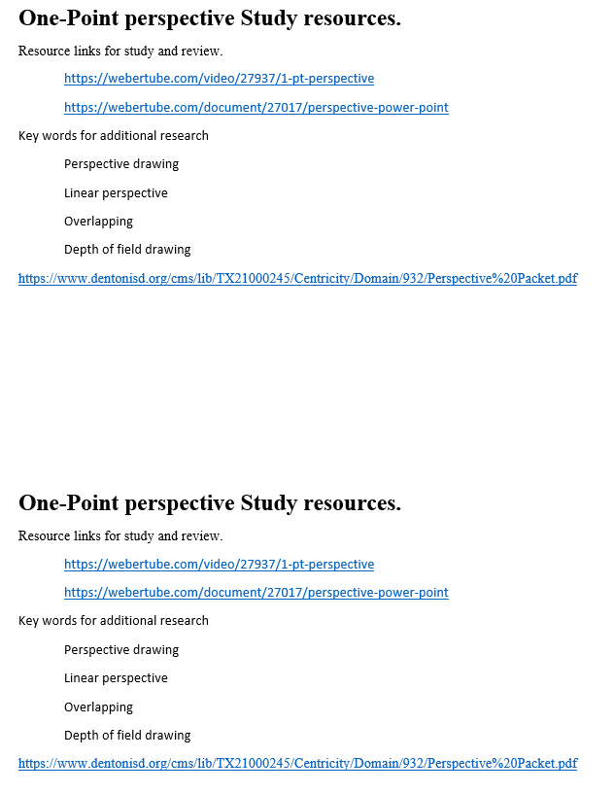

Bell Activity handouts (Lesson 1)
Bell Question
“What do you know about depth of field and space in works of Art?”

-Be Sure to attach this to your Sketch book for credit.
-Remember if you have lost your sketchbook you can still do sketchbook tasks on regular paper.

-------------------------------------------------------------------------------------------------------------------------------

Bell Question
“What do you know about depth of field and space in works of Art?”

-Be Sure to attach this to your Sketch book for credit.
-Remember if you have lost your sketchbook you can still do sketchbook tasks on regular paper.

-------------------------------------------------------------------------------------------------------------------------------

Bell Question
“What do you know about depth of field and space in works of Art?”

-Be Sure to attach this to your Sketch book for credit.
-Remember if you have lost your sketchbook you can still do sketchbook tasks on regular paper.

Overlapping step by step notes. (lesson 1)
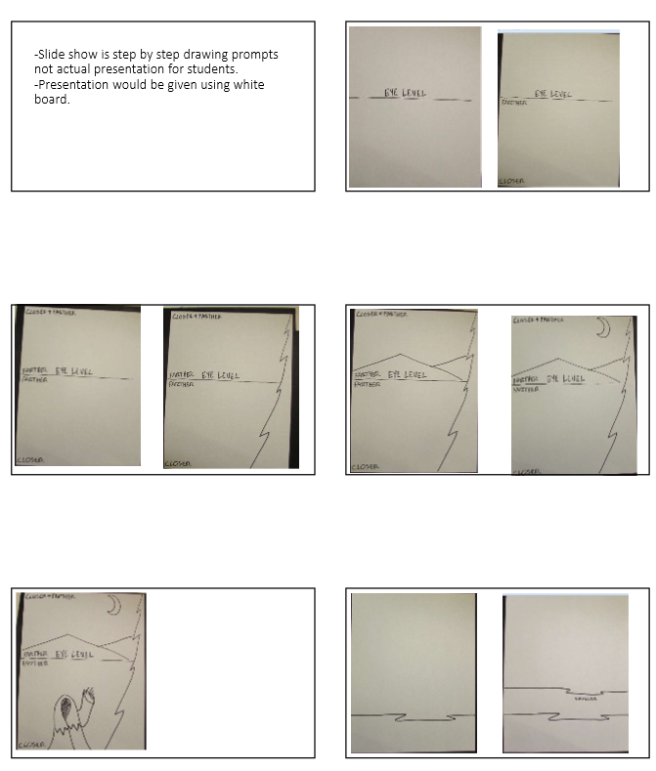
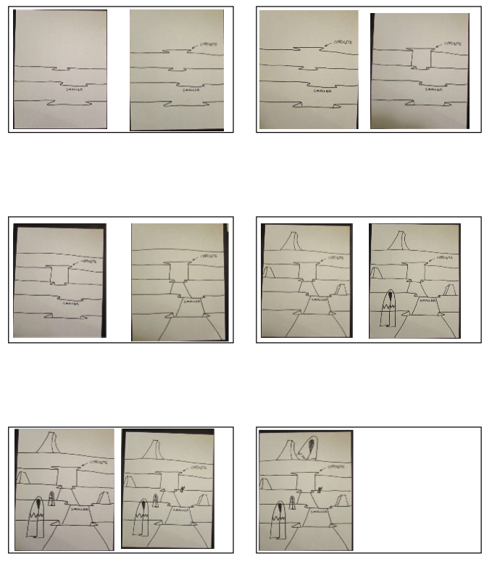
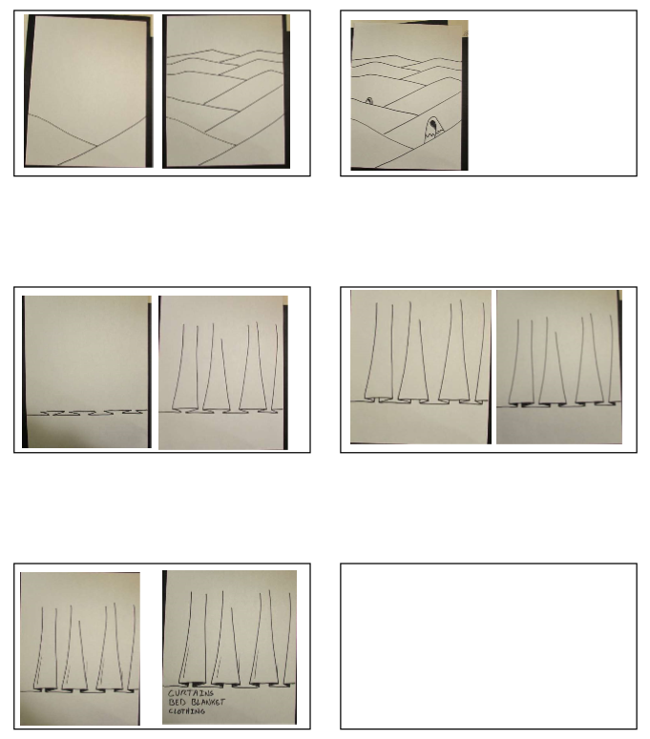

Power Point “Space and Depth of Field”
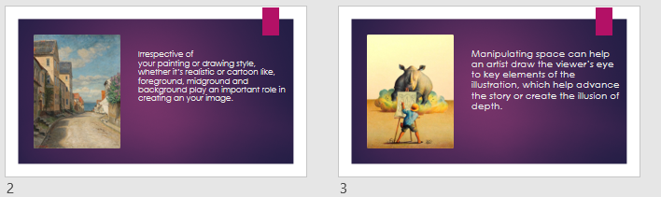
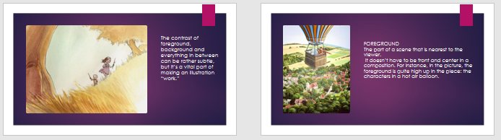
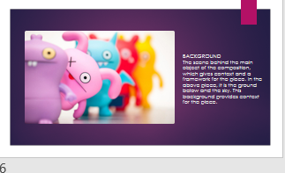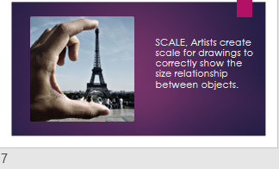
(Example of assessment document lesson 2)
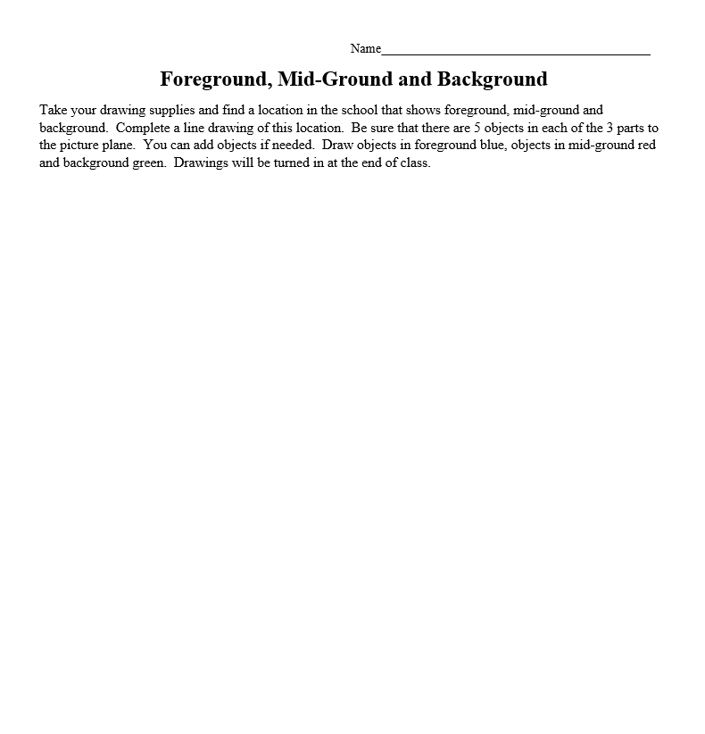

(Slides used for discussion of parallel and linear perspective, Lesson 3 discussion resources)
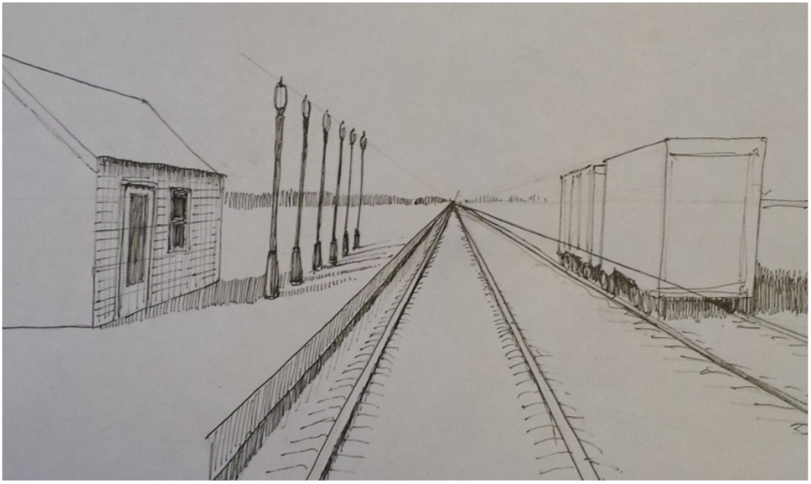
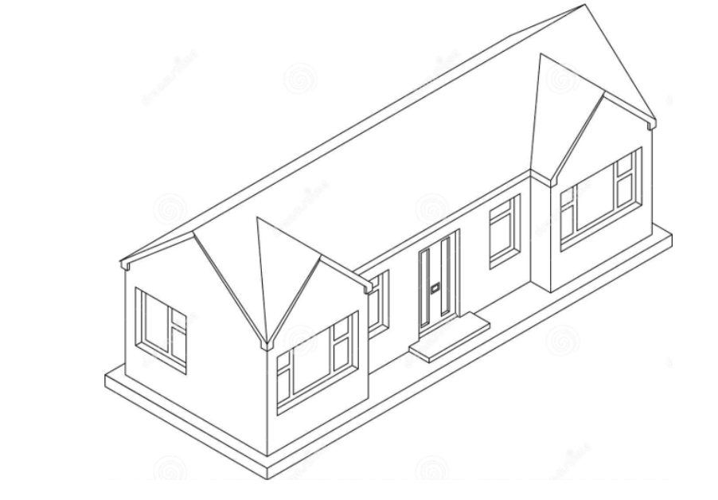
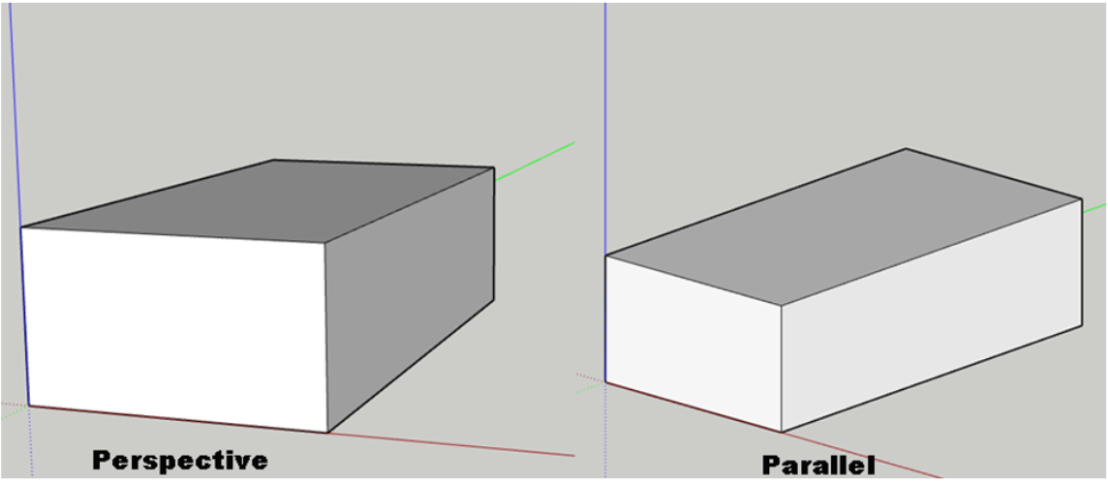

(Step by step guide for lesson 3, one point perspective method)
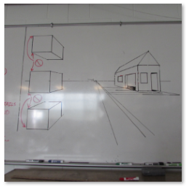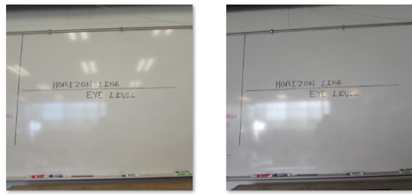
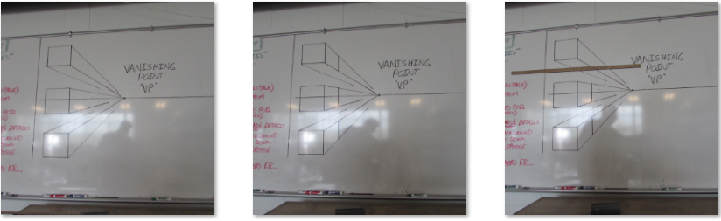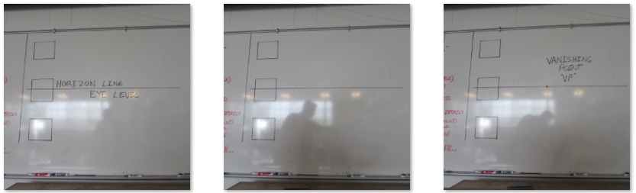
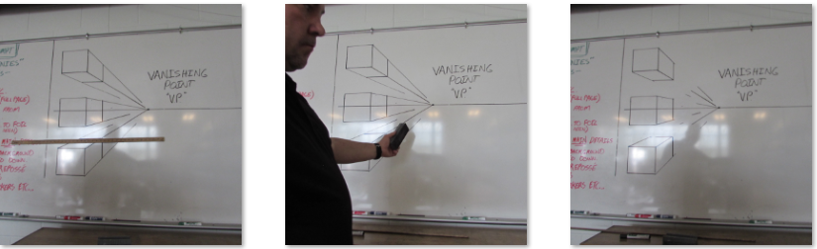
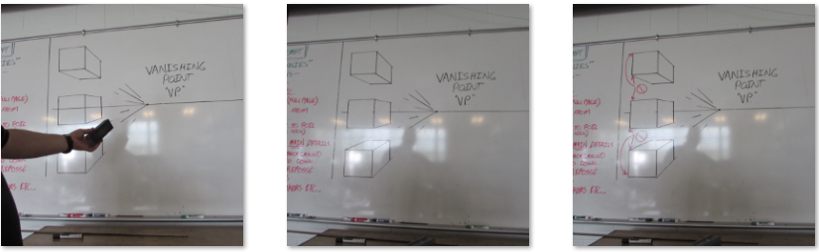
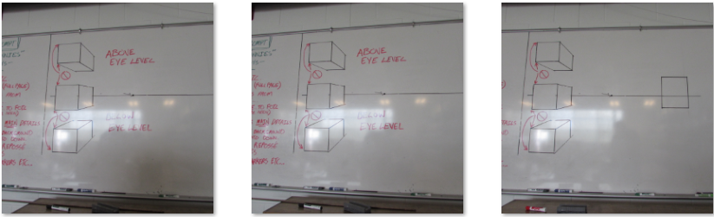
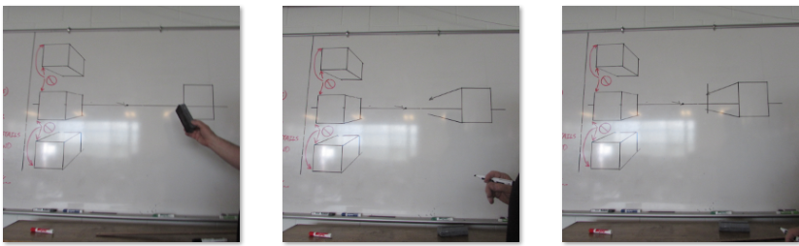

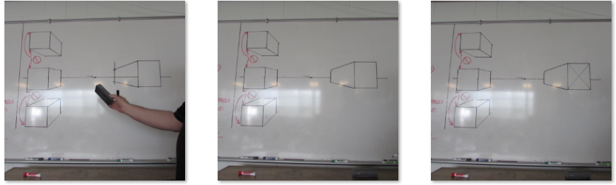
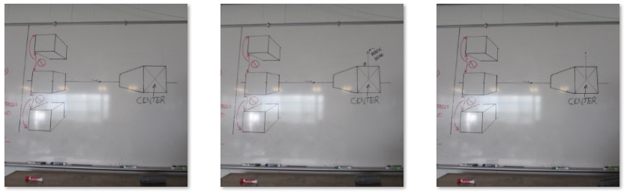
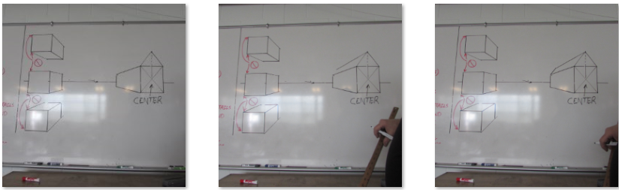
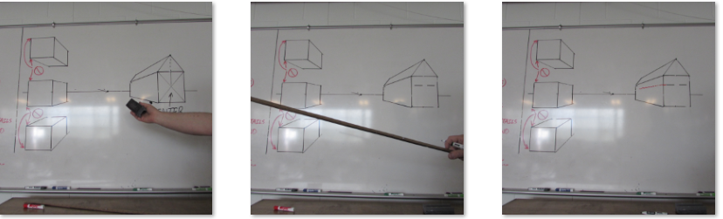

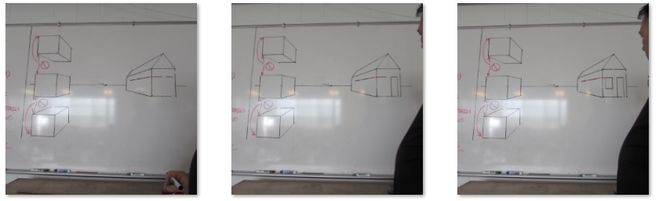
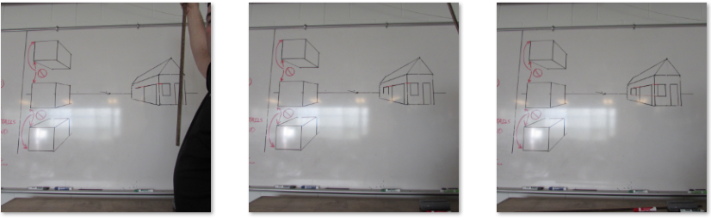
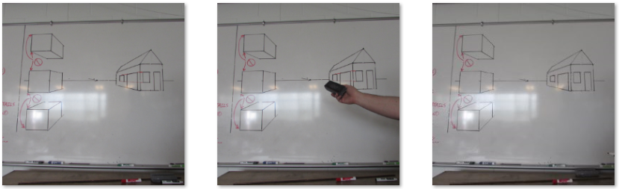
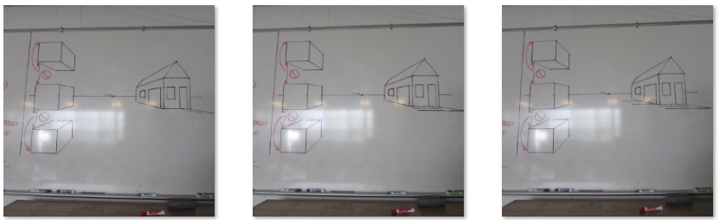
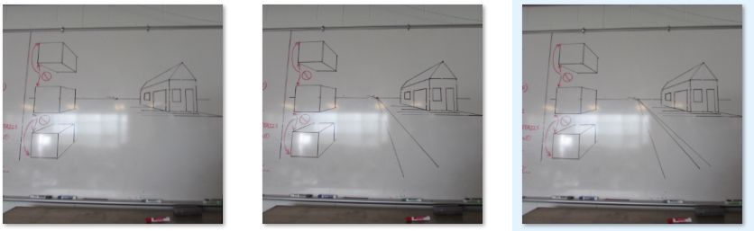
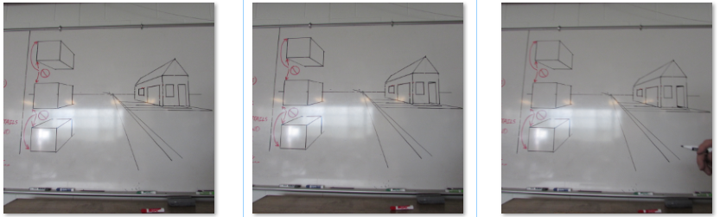

(Example of final assessment Instructions, Hard copy or digital)

References

